Name: Muhamad Fadhli Akbar

Class: Cortana

ASSIGMENT 4 SQL

Run the following queries.   
1. On orders create a single index on two fields customerid and orderid

*CREATE INDEX idx_orders_customerid_orderid ON orders (customerid, orderid);*

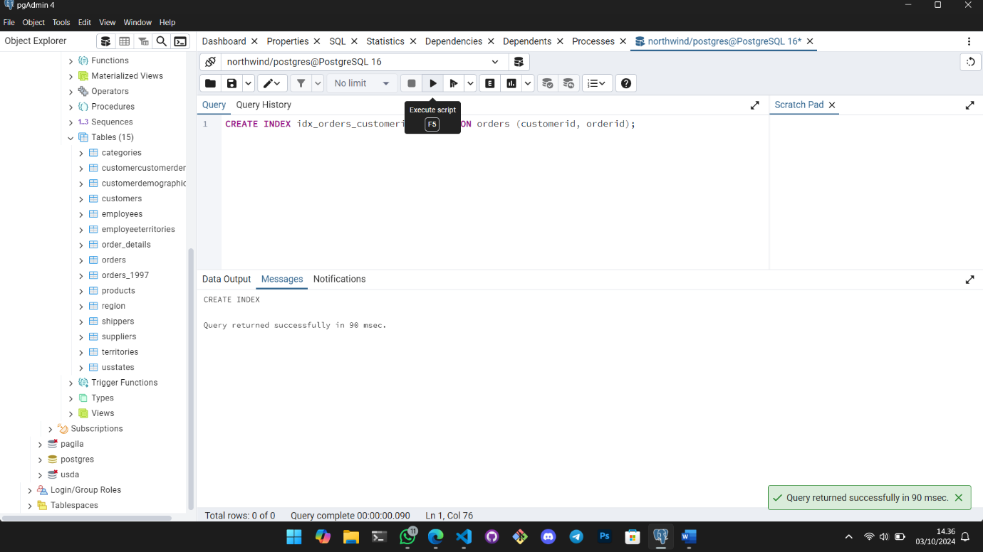  
2. Drop idx_orders_customerid_orderid index on orders table

*DROP INDEX IF EXISTS idx_orders_customerid_orderid;*

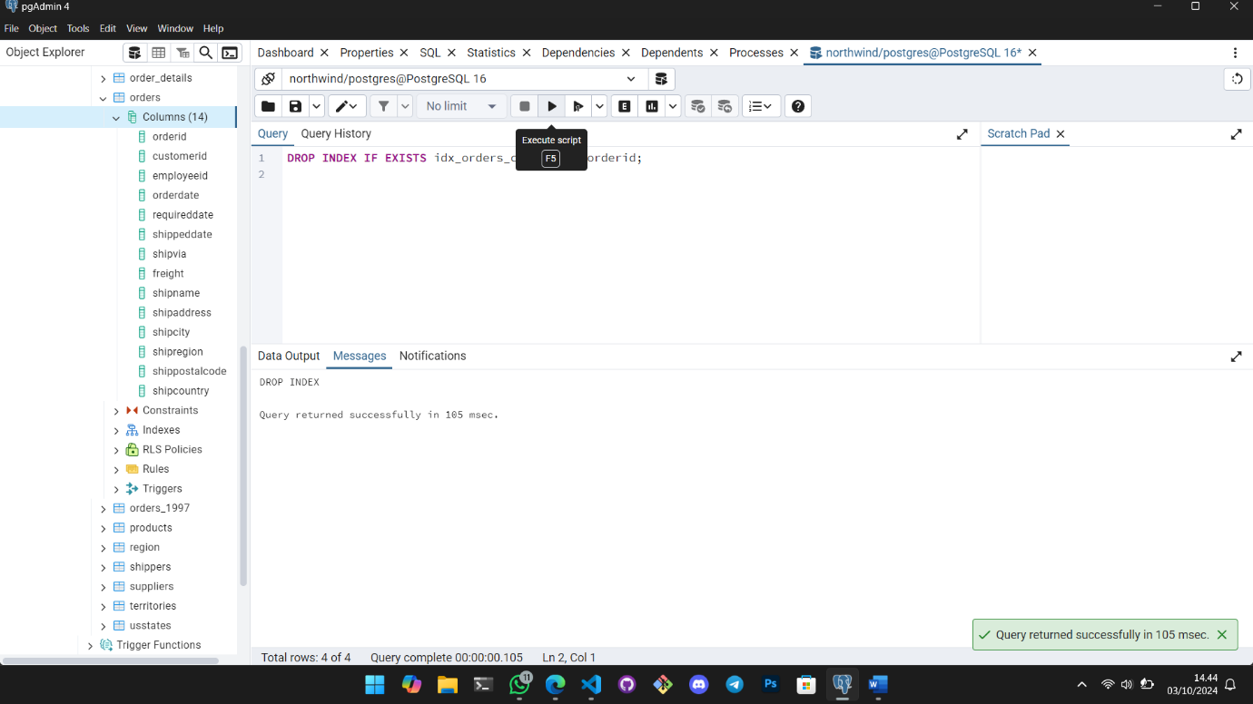  
3. Create a table for returns (should have id for the record, customerid, date returned, productid,   
quantity and orderid).

*CREATE TABLE returns (*

*id SERIAL PRIMARY KEY,*

*customerid INT,*

*returndate DATE,*

*productid INT,*

*quantity INT,*

*orderid INT*

*);*

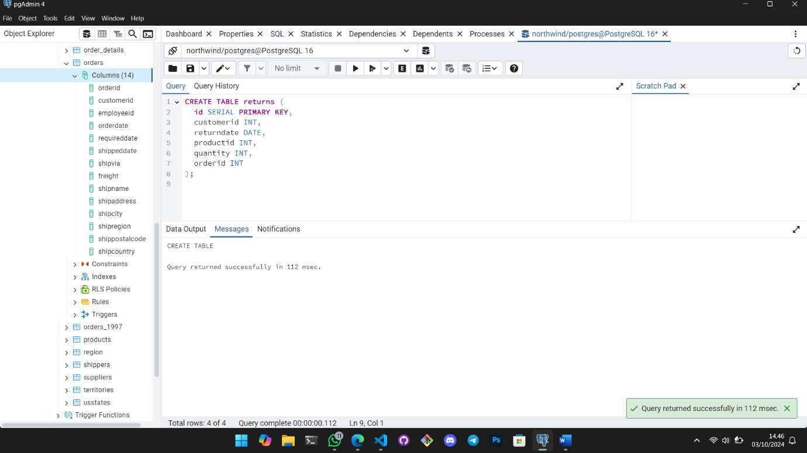  
4. On returns table rename returndate to return_date

*ALTER TABLE returns RENAME COLUMN returndate TO return_date;*

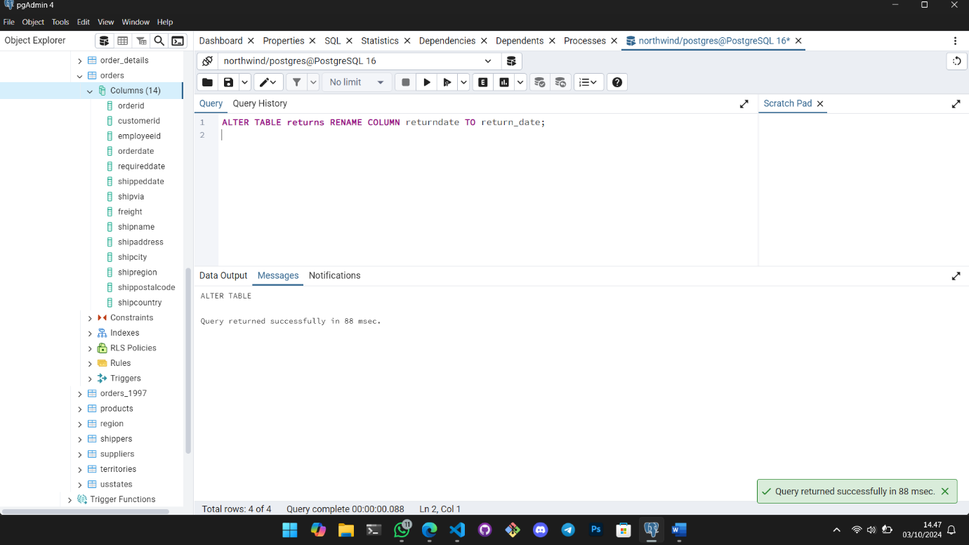  
5. Rename returns table to bad_orders

*ALTER TABLE returns RENAME TO bad_orders;*

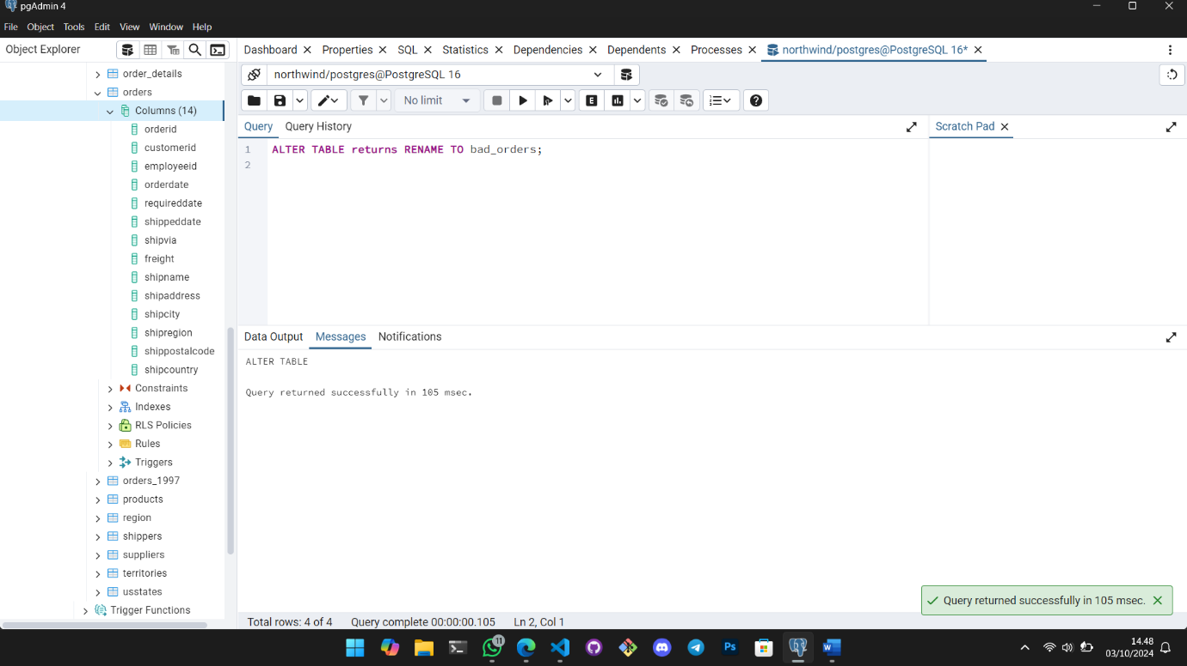  
6. On bad_orders table add a text field called reason

*ALTER TABLE bad_orders ADD COLUMN reason TEXT;*

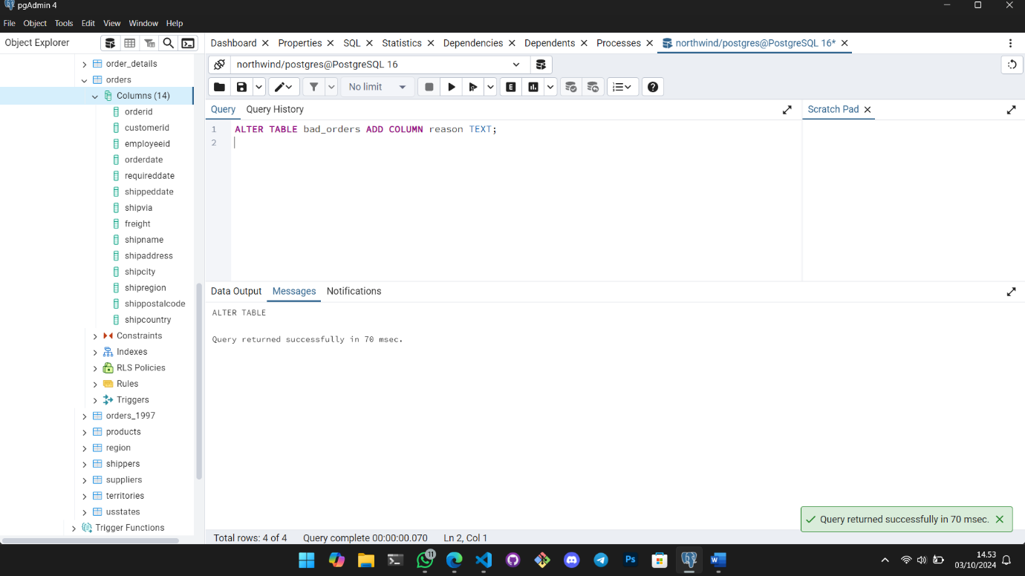  
7. On bad_orders table remove reason field

*ALTER TABLE bad_orders DROP COLUMN reason;*

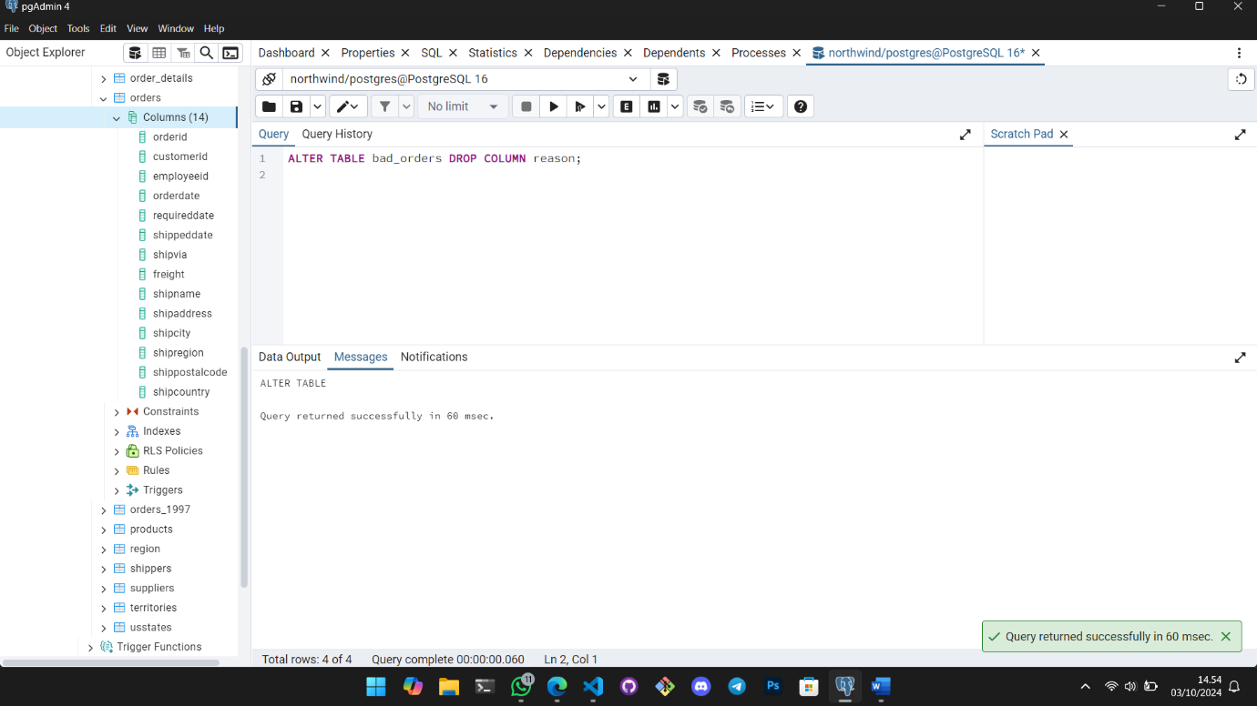  
8. On bad_orders table changes the quantity field to int

*ALTER TABLE bad_orders ALTER COLUMN quantity TYPE INT;*

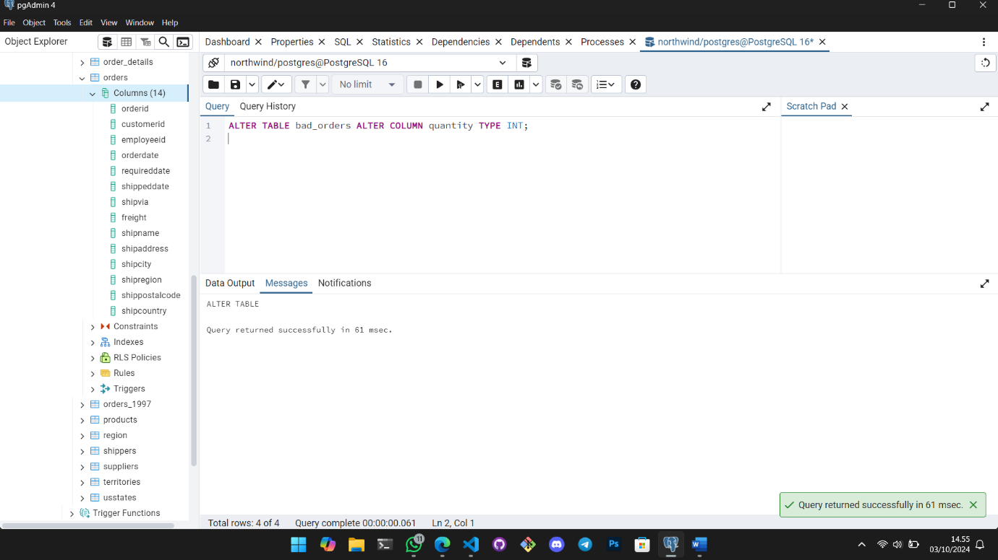  
9. Drop the bad_orders table   
*DROP TABLE IF EXISTS bad_orders;*

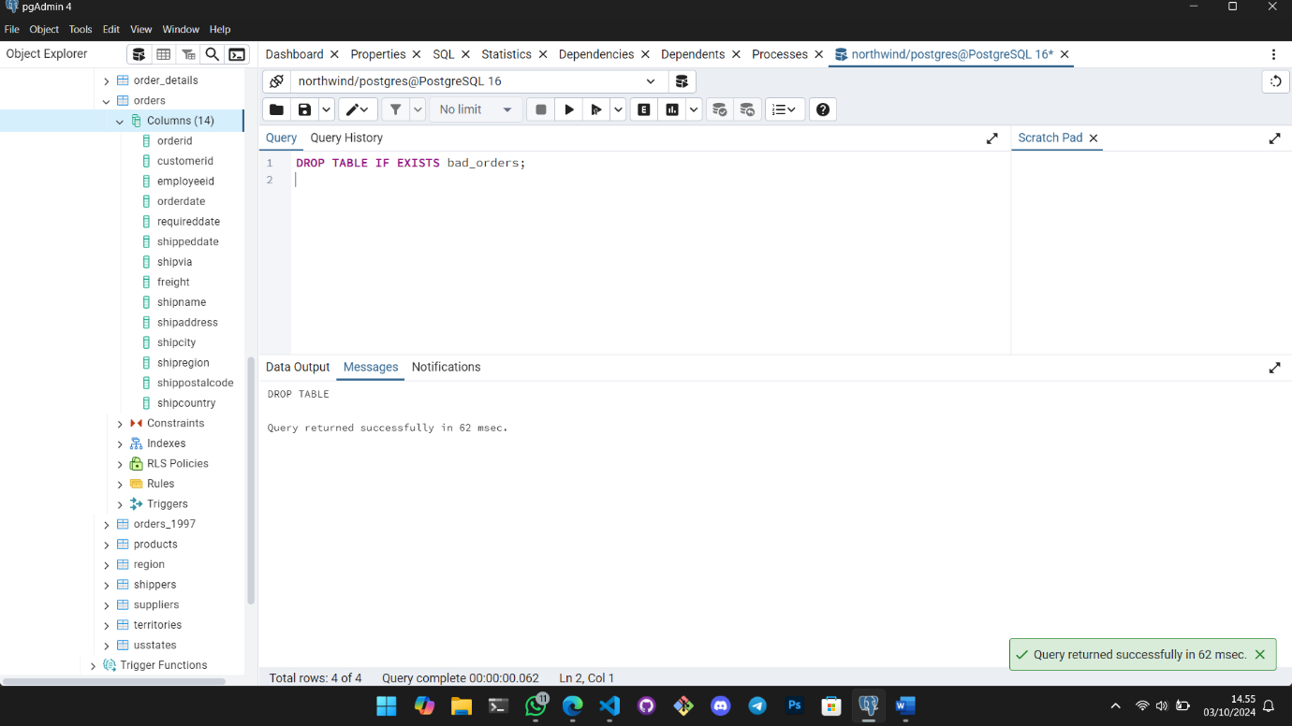

**THANK YOU**